W Arockia Franciska

C Harsha Vardhini

Integrated Farm Security System

Table of Contents

1. Introduction 4

2. Literature Survey 4

2.1 Survey 1: 4

2.2 Survey 2: 5

2.3 Survey 3: 5

2.4 Survey 4: 5

2.5 Disadvantages of Existing System: 6

2.5.1 High Cost: 6

2.5.2 Prone to Seasonality: 6

2.5.3 Highly Inefficient: 6

2.5.4 Injuries to Animals/Harmful to Animals: 6

2.5.5 Lack in preventive measures: 6

3. Proposed Solution 6

3.1 Advantages of the Proposed System: 6

3.1.1 Self-governing system: 6

3.1.2 Seasonality Independence: 6

3.1.3 Minimal Requirement for High-Performance or Costly Hardware: 6

3.1.4 High Efficiency: 7

3.1.5 High Classification Accuracy: 7

4. Statement of the Issue 7

5. Information Collection 7

5.1 Information collected from MSCOCO website: 7

5.2 Information collected from a few recent publications: 7

5.2.1 Object Detection: 7

5.2.2 Sound Generation and Playback: 7

5.2.3 Alert Notifications: 8

5.2.4 Machine Learning Integration: 8

5.2.5 Computer Vision Integration: 8

5.3 Information Collected from Kaggle: 8

6. Project Application 8

7. Project Execution 8

7.1 Application Development 8

7.1.1 Computer Vision: 8

7.1.2 Artificial Intelligence: 9

7.2 Experimental Setup 11

8. Conclusion 11

9. Future Developments 11

Abstract:

Everybody acknowledges that India’s largest industry is Agriculture, but due to the Economic climate at present, crop loss has become an ultimate man-wildlife conflict. Thus, farmers have relied on guards to protect the Agricultural lands. In this case, harming or punishing the animals is not the remedy. To save crops, animals, and human beings, it is necessary to establish a good solution using technology. This technical abstract proposes an integrated solution to mitigate challenges faced by the Indian agricultural sector, specifically addressing man-wildlife conflict. To detect and identify animals and humans we use machine learning and computer vision (AI) techniques. The proposal emphasizes ethical considerations, highlighting the intention to coexist with wildlife without causing harm.

# Introduction

Agriculture plays a vital role in meeting the dietary requirements of the population and serves as a key source of raw materials for various industries. However, the increasing interference of wild animals in agricultural areas poses a significant threat to crop yields. Notably, the damage caused by creatures such as wild boars, macaques, porcupines, deer, monkeys, and bears has escalated, leading to substantial crop losses and occasional human casualties. Stringent wildlife regulations further exacerbate the plight of small-scale farmers, who may incur losses of up to 50% [1] of their harvest without recourse to drastic measures. Farmers install electric fences as a protective measure against wild animals, but this solution poses a risk to humans who may accidentally encounter electrocution when attempting to cross the electric fence. Between 2010 and 2020, data compiled by the NGO Wildlife Protection Society of India (WPSI) reveals a concerning trend of around 1300 wild animals succumbing to electrocution in the country. Elephants bore a significant brunt, with 630 of them meeting their demise due to electrocution in the past decade. Assam reported the highest number of elephant electrocutions, accounting for 120 of the tragic incidents. The toll extends beyond elephants, encompassing over 500 elephants, 220 flamingos, 150 leopards, and 46 tigers, among other species, falling victim to electrocution across India. [7]

Tragically, the impact of electrocution is not limited to wildlife alone, as the data reveals that over 100 farmers lost their lives to electrocution in India during the same period. These alarming figures underscore the need for increased awareness, preventive measures, and stricter regulations to mitigate the devastating consequences of electrocution on both wildlife and human populations.

Computer vision offers wide-ranging applications across various industries, including the medical sector, robotics, remote sensing, machine vision, and content-based image retrieval. Its utility extends to problem-solving in numerous domains. In the realm of security, computer vision finds applications in automatic surveillance, access control, and attendance tracking. Moreover, it proves invaluable in detecting diseases in trees through the analysis of leaves, blossoms, or fruits, and monitoring the quality of agricultural goods.

In the agricultural sector, a vital application of computer vision is mitigating the threats posed by wild animals particularly in areas close to forests, agricultural lands face frequent wildlife attacks, compelling farmers to install electric fences. However, the implementation of electric fences introduces a risk to humans who may unintentionally face electrocution. In this scenario, computer vision technology serves as a protective measure, aiming to enhance safety and reduce unintended harm caused by electric fences. These attacks not only pose a serious threat to farmers but also lead to substantial financial losses due to the significant damage inflicted on agricultural products. Leveraging computer vision in agriculture holds the potential to mitigate these challenges and enhance protection against the impact of wildlife interference

# Literature Survey

The agricultural sector remains paramount in the Indian economy, serving as a linchpin for both economic development and human sustenance. Even in contemporary times, the use of human-shaped scarecrows persists in agricultural fields to deter birds and other animals from disrupting and consuming nascent crops. However, these traditional methods exhibit various shortcomings, underscoring the need to address and enhance agricultural security.

This work is dedicated to proposing a system designed to overcome these limitations. The primary objective is to introduce a flexible and adaptive system that can not only identify intruders but also actively monitor for any potentially hazardous activities. In case of such threats, the system is equipped to promptly notify the farm owner. This innovative approach is aimed at providing farmers with a practical means to ensure the comprehensive safety of their farmlands, offering protection against potential attacks or trespassing incidents. The overarching goal is to contribute to the ongoing discourse on advancing agricultural security in a rapidly evolving landscape. [1]

**Summary**: This journal contributes valuable insights into the application of Artificial Intelligence (AI) and its integration with motion detectors and Infrared (IR) sensors within the agricultural sector. The study delves into how these technologies can be harnessed to enhance and optimize various aspects of agricultural practices, bringing forth a deeper understanding of their potential impact on the field.

The study recognizes the limitations of age-old practices and advocates for the application of computer vision techniques to address the issue of animal attacks. Specifically, the paper introduces a method for animal identification in images, leveraging the W-COHOG feature vector, an enhanced version of Histogram Oriented Gradients. Building upon this, the study incorporates Co-occurrence Histograms of Oriented Gradients (COHOG) to further refine accuracy. The research employs a LIBLINEAR classifier to enhance accuracy, particularly in dealing with high-dimensional data. To validate the effectiveness of the proposed method, the study conducts tests on benchmark datasets, namely the Wild-Animal and Camera Trap datasets. This systematic approach aims to offer a more accurate and efficient solution to the persistent problem of wild animal attacks on agricultural farms, showcasing the potential of computer vision techniques in enhancing agro-farm security. [3]

**Summary**: This journal focuses on the application of Computer Vision in enhancing agricultural safety [4]. The study introduces the MobileNet SSD (Single Shot Detection) technique, extensively utilized in the project. MobileNet SSD stands out for its significant efficiency gains compared to models like ResNet, making it particularly suitable for deployment on low-end hardware devices. The primary concern addressed in this paper is the potential damage to crops by wild animals. The monitoring of animal presence in agricultural areas is identified as a crucial step. Following this, the activation of preventive measures to deter dangerous animals becomes imperative. To enhance the efficacy of farm protection, the study proposes a strategy utilizing pervasive wired network devices.

Operational amplifier circuits, commonly employed for detecting animal intrusion from external areas, form a key component of the suggested monitoring plan. The objective is to provide an early warning system that signals potential wild animal infiltration and potential harm to the farm [5]. This research emphasizes the practical application of advanced technologies like Computer Vision to proactively address challenges in agricultural safety and protection against wildlife threats.

**Summary**: In this paper, we learn about animal detection and protection of crops using embedded systems.

Animal detection and alarm system designed for implementation in farming practices. The aim is to deter wild animals from entering farm fields, thereby minimizing the potential harm they may cause to the environment and the individuals working in the vicinity. Leveraging machine learning and computer vision techniques (AI), the system is capable of recognizing various animals, facilitating the detection and identification of those attempting to enter the field. Upon detection, the system employs sound and signal generation in the form of an Alarm System to divert the animals. Simultaneously, field owners and relevant officials are promptly informed of the situation through messaging, providing them with real-time data. [6]

**Summary**: In this paper, we learn about Computer Vision (AI) And Machine Learning Techniques for Animal Detection and Alarm Systems in Agricultural Farms.

# Disadvantages of Existing System:

# High Cost:

The current system is associated with high costs, likely stemming from expensive equipment and infrastructure requirements. This financial burden can be a significant drawback for farmers, especially those with limited resources.

# Prone to Seasonality:

The system appears to be sensitive to seasonal variations. This limitation may result in reduced effectiveness during specific times of the year, potentially leaving agricultural operations vulnerable during certain seasons.

# Highly Inefficient:

The inefficiency of the existing system implies that it may not be performing optimally. This could lead to compromised outcomes, reduced accuracy, and an overall lack of effectiveness in achieving its intended objectives.

# Harmful to Animals:

The current system may pose a risk of injuries to animals or be inherently harmful to them. This ethical concern not only raises questions about animal welfare but could also have legal implications.

# Lack in preventive measures:

Detection and alerts are implemented, yet no additional preventive measures are initiated thereafter.

# Statement of the Issue

Agriculture holds immense significance in India, with various animals like buffalo, cows, goats, birds, and wild elephants, posing a threat to crop integrity. This challenge is particularly pronounced for farmers with limited land resources, as animal intrusion result in substantial financial losses that are often beyond the means of the majority of Indian farmers. The inability of farmers to constantly safeguard their fields throughout the day pushed them to install physical or electric fence to protect the crops from wild animals. Electric fences, typically employed for containing animals, can also prove highly effective in preventing the entry of specific predators, including dogs, wolves, coyotes, and bears. These potential threats to livestock, horses, or exotic animals can be effectively deterred by the use of electric fencing. Electric fencing serves more as a psychological barrier, than a physical barrier. But this solution poses a risk to humans and animals which may accidentally encounter electrocution when attempting to cross the electric fence.

To address these concerns, an animal and human detection system has been devised. This system not only identifies the presence of animals and humans but also issues warnings and guides animals away from danger areas without causing harm. Additionally, the system integrates a self-governing mechanism that deactivates the electric fence upon detecting a human presence and varies the electric fence voltage based on the type of animals being contained or deterred.

Recognizing the increasing application of Computer Vision in agriculture for enhanced productivity through task automation, we propose an AI-based system. This system utilizes cameras to monitor the fields, promptly detecting intrusions by both animals and humans. The system can issue alerts to the farmer and, if necessary, autonomously take predefined actions. This integrated approach aims to provide a comprehensive solution for safeguarding agricultural fields in India.

# Electric Fence Analysis

Effective electric fencing varies based on the specific needs dictated by the nature and size of the animals to be contained. For instance, aggressive animals like bulls may require a different fencing voltage compared to docile ones like dairy cows. An electric fence designed to deter deer, differs from one intended to repel smaller pests such as rabbits or larger predators like foxes. The appropriate voltage limit for electric fences can vary based on the type of animals you are trying to contain or deter. The sensitivity of animals to electric shocks can differ, and factors such as coat thickness, environmental conditions, and an animal's health can also influence their response to an electric fence. Below are general voltage guidelines for different types of animals,

|  |  |  |  |
| --- | --- | --- | --- |
| Voltage Minimum Requirements | | | |
| Animals | **Minimal Recommended voltage on fence line\*** | **Animals** | **Minimal recommended voltage on fence line\*** |
| Deer/Exotics,  Sheep/goats,  Predators | 4000-5000+ volts | Nuisance pests | 1000-2000 volts |
| Bulls/Bisons | 3000-4000+ volts | Pets | 700-1000 volts |
| Cows, Horses, Pigs | 2000-3000 volts | Poultry | 500-900 volts |

Table 1: Voltage Requirement [12]

The voltage used in electric fences can vary based on the type of animals being contained or deterred. Different animals have different levels of sensitivity to electric shocks, so the voltage used in electric fences is often adjusted accordingly. Here are some general considerations:

# Small Animals (e.g., Pets, Rodents):

Pets are generally more sensitive to electric shocks, so lower voltage levels are often sufficient to act as a deterrent. The idea is to create a deterrent without causing harm. Energizers designed for these applications may have lower voltage settings to provide an effective deterrent without posing a risk of injury.

# Livestock (e.g., Cattle, Sheep):

Larger animals like cattle and sheep generally require higher voltages to create an effective deterrent. Energizers for livestock applications typically operate at moderate to high voltage levels to ensure that the electric shock is strong enough to deter the animals from attempting to breach the fence.

# Predators (e.g., Wolves, Coyotes):

Electric fences designed to deter predators may use higher voltage levels than those used for livestock. Predators are often more determined and agile, so a stronger shock is needed to discourage them effectively.

# Wildlife (e.g., Deer, Elephants):

Fences designed to deter wildlife, especially larger animals like deer or elephants, may require even higher voltage levels. The goal is to create a strong deterrent that is effective against the size and strength of the particular wildlife species.

# Domestic Animals (e.g., Horses, Pigs):

The voltage used for domestic animals can vary depending on the species and individual animal. Some animals may be more sensitive than others, so adjustments may be needed to find an effective but humane level of deterrent.

# Human Being:

Typically, low-voltage shocks (up to 50 volts) are considered less hazardous. While they may not cause significant harm, they can still startle or cause minor discomfort. However, Voltages between 50 and 600 volts are considered moderate, and they have the potential to cause injury or even be fatal, especially if the current flow is substantial. High-voltage shocks, above 600 volts, pose a severe risk of injury or death. At higher voltages, the potential for serious harm, internal injuries, and cardiac arrest increases significantly.

Prioritizing safety and adhering to recommended limits in the design and operation of electric fences is crucial to prevent harm to both animals and humans. Unfortunately, in many instances, electric fence standards are not followed, leading to the unfortunate loss of innocent lives, both among animals and humans.

# Proposed Solution

We propose the implementation of an artificial intelligence (AI)-based surveillance system designed to identify and track the presence of animals and humans in the farm. Cameras strategically positioned at potential entry points for animals capture footage, which is processed by the system utilizing OpenCV and computer vision. The system utilizes a pre-trained Convolutional Neural Network (CNN) model to accurately identify the presence of both animals and humans within the farm. When an intrusion is detected, a siren is activated to serve as a deterrent for animals. Additionally, in the case of human detection, the system autonomously deactivates the electric fence as a precautionary measure. In case of animals, voltage used in electric fences varied based on the type of animals being contained or deterred. Different animals have different levels of sensitivity to electric shocks, so the voltage used in electric fences is adjusted accordingly.

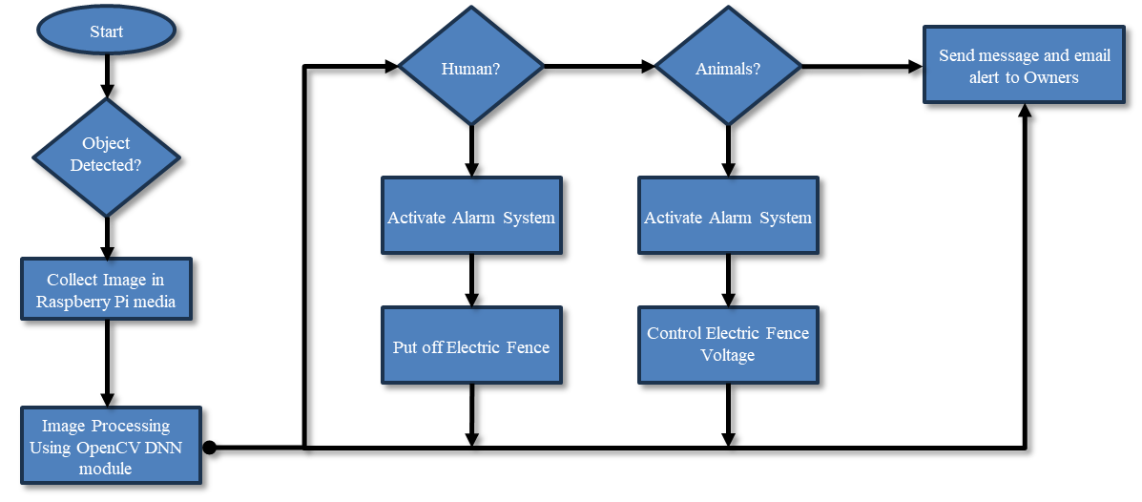

Figure 1: Proposed Solution Flowchart

# Advantages of the Proposed System:

# Self-governing system:

Automated system for animal detection and protection.

# Seasonality Independence:

Unlike existing systems, the proposed system is not affected by seasonality variations, ensuring consistent performance throughout the year.

# Minimal Requirement for High-Performance or Costly Hardware:

The system operates efficiently with minimal need for exceptionally high-performance or expensive hardware, enhancing accessibility and affordability.

# High Efficiency:

The proposed system is designed to be highly efficient, ensuring optimal performance in identifying and addressing potential threats.

# High Classification Accuracy:

The accuracy of animal classification is notably high, contributing to the system's effectiveness in detecting intrusions and minimizing false alerts.

# Information Collection

# Information collected from MSCOCO website:

The graphic dataset, known as MS COCO (Common Objects in Context), has become a cornerstone in various computer vision applications such as object detection, face detection, pose estimation, and more. Microsoft released this substantial dataset, encompassing object detection, segmentation, and captioning tasks. Widely adopted by experts in computer vision and machine learning, the MS COCO dataset is a go-to resource for a diverse set of computer vision tasks. The name "COCO," denoting Common Objects in Context, reflects the dataset's purpose of enhancing image recognition capabilities.

# Information collected from a few recent publications:

To detect objects, play or generate sounds, and send alert notifications in a project, various technologies and techniques can be employed. Here's an overview of the technologies commonly used for each aspect:

# Object Detection:

Technologies: Convolutional Neural Networks (CNN), Region-based CNN (R-CNN), Single Shot Multibox Detector (SSD), You Only Look Once (YOLO).

Techniques: Transfer learning, Fine-tuning pre-trained models, Anchor box optimization.

# Sound Generation and Playback:

Technologies: Digital Audio Synthesis Libraries (e.g., PyDub, LibROSA), Text-to-Speech (TTS) engines.

Techniques: Signal processing, Mel-frequency cepstral coefficients (MFCC) for speech, Generative models for synthetic sounds.

# Alert Notifications:

Technologies: Messaging services (e.g., Twilio, Push Notifications), Email APIs.

Techniques: Event-triggered notifications, Real-time communication protocols.

# Machine Learning Integration:

Technologies: TensorFlow, PyTorch, Scikit-Learn.

Techniques: Supervised learning for classification (e.g., detecting objects), Unsupervised learning for anomaly detection, Reinforcement learning for decision-making.

# Computer Vision Integration:

Technologies: OpenCV, TensorFlow Object Detection API, Dlib.

Techniques: Image preprocessing, Feature extraction, Neural network architectures designed for computer vision tasks.

# Information Collected from Kaggle:

Data collected from the Kaggle website is a valuable resource for users engaging in various data science activities. Kaggle serves as a platform where users can discover and share datasets, analyze and build models within a web-based data science environment. It facilitates collaboration with other data scientists and machine learning specialists, providing a space for knowledge exchange and collective problem-solving. Additionally, Kaggle hosts competitions that challenge participants to address specific data science challenges, fostering a dynamic and competitive learning environment within the community.

# Project Application

* Enabling automatic animal intrusion detection empowers farmers to enhance yield and revenue.
* Industries dependent on agriculture for their operations gain improved control over the supply chain.
* AgriTech sectors can increasingly rely on AI to address labor shortages during seasonal fluctuations inherent in agriculture.
* Government agencies and policymakers can leverage the system to enhance crop supply assurance and prevent significant inflation in crop prices.

# Project Execution

The implementation phase is the stage where all planned operations are executed. It involves putting a plan into action, completing it, or making it operational. This encompasses the execution of strategies, methods, and other designs to bring about a desired outcome. In the realm of information technology, implementation refers to the comprehensive set of procedures required to set up new hardware or software, ensuring its proper functionality in a given environment. These procedures encompass installation, configuration, execution, testing, and any necessary adjustments.

# Application Development

# Computer Vision:

Computer vision research aims to emulate the complexity of the human visual system to enable computers to recognize and analyze objects in images and videos, similar to human capabilities. While the computer vision problem might seem straightforward, even manageable by very young babies, recent advancements in artificial intelligence have propelled it to surpass human performance in tasks involving object identification and labeling. The progress in computer vision is largely attributed to developments in deep learning, neural networks, and artificial intelligence. The abundance of data generated in contemporary times plays a pivotal role, serving as the training material for computers to refine their vision capabilities.

OpenCV, a substantial open-source library, is a powerhouse for computer vision, machine learning, and image processing. Its contributions are paramount in achieving real-time operations, a critical aspect in modern systems. OpenCV proves versatile, allowing users to search for faces, objects, and even human handwriting within images and videos. In collaboration with other libraries, such as Numpy, Python becomes adept at handling the OpenCV array structure for comprehensive analysis. The recognition of visual patterns in their diverse forms is accomplished through the application of mathematical techniques and vector space.

# Artificial Intelligence:

The functioning of neurons in the human brain and nervous system is emulated in a system, either in hardware or software, known as an artificial neural network. Artificial neural networks, a subset of deep learning technology, fall under the broader category of artificial intelligence. Within deep learning, various types of neural networks are employed as part of machine learning. Many experts assert that these algorithms represent a promising avenue for achieving genuine artificial intelligence as they are designed to emulate the workings of our brains (Artificial Intelligence).

A sequence-to-sequence model comprises two recurrent neural networks. An encoder processes the input, while a decoder handles the output. The settings employed by the encoder and decoder can be either identical or distinct. This model proves particularly valuable when dealing with input and output data of differing lengths. Key applications for sequence-to-sequence models include machine translation, Chabot, and question-answering systems. [6]

Let's examine the fundamental component of any neural network:

**Input Layer**: This layer serves as the input for the model, with the number of features in our input corresponding to the number of neurons in the input layer.

**Hidden Layer**: The input features are transmitted to the hidden layer(s) where various processes and activities occur. Multiple hidden layers may exist, and these layers undergo mathematical operations such as matrix multiplication, convolutions, pooling, etc., in conjunction with an activation function.

**Output Layer:** This layer is employed to generate probability scores using sigmoid or softmax functions, which are subsequently transformed into the output of our model.

**Image Layer:** To implement an image input layer, create an image input layer where images are introduced into a network, and data standardization is applied. Use the input Size option to specify the image size, considering factors such as the number of color channels, width, and height, all of which influence the image dimensions.

**Sequence Layer:** In a network, sequence data is received through a sequence input layer. In scenarios like machine translation, where input and output sequences often have varying lengths, the entire input sequence needs to be presented before predicting the target. When referring to "sequence-to-sequence models" without additional details, it typically implies a more intricate configuration.

**Convolution Layer:** Convolutional layers play a fundamental role in convolutional neural networks. Convolution, a simple process of applying a filter to an input to generate an activation, forms the basis of these layers. Repeatedly applying the same filter to an input results in the creation of a feature map, showcasing the locations and extent of a recognized feature in the input, such as an image. What sets convolutional neural networks apart is their ability to autonomously learn numerous parallel filters tailored to a training dataset while adhering to the specifications of a specific predictive modeling problem, such as image classification. Consequently, input images can possess highly unique features that may be identified anywhere in the image.

**Softmax and Classification Layer:** Softmax finds application in the final layer of image classification networks such as Convolutional Neural Networks (CNNs), for instance, VGG16 used in ImageNet competitions. Additionally, it is a crucial component in deep learning architectures for diverse applications like pneumonia detection [9], cardiac arrhythmia detection [10], and the classification of health images using machine learning algorithms [11, 12, 13].

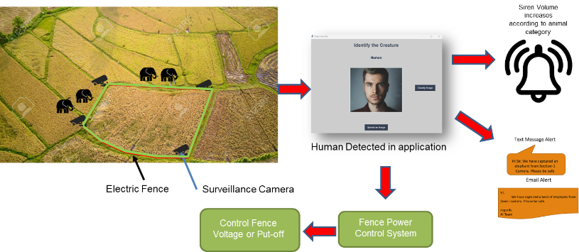

Figure 2: Animal and Human Detection in Application

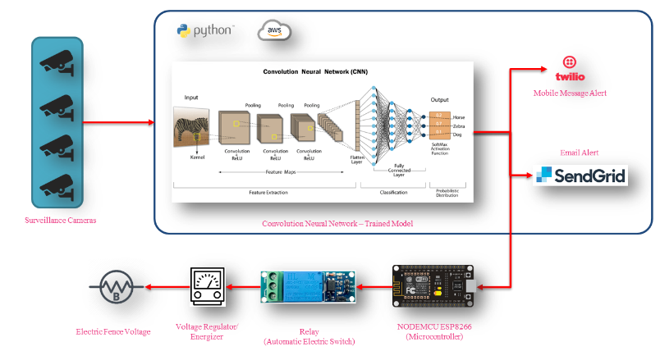

Figure 4: System Architecture

# Experimental Setup

# Conclusion

The Integrated Farm Security System not only addresses critical challenges in the agriculture sector but also presents lucrative business opportunities. With a favorable economic climate, increasing investment, and the continuous growth of the agri-tech sector, businesses in the field of farm security systems are well-positioned to contribute to the sustainable development of India's agriculture industry while reaping the benefits of a dynamic and expanding market.

# Future Developments

Continued research and development in AI, machine learning, and computer vision will further enhance the capabilities of the Integrated Farm Security System. Future iterations may include additional features such as weather monitoring, pest detection, and predictive analytics for proactive agricultural management.

REFERENCES

[1] S. Yadahalli, A. Parmar and A. Deshpande, "Smart Intrusion Detection System for Crop Protection by using Arduino," 2020 Second International Conference on Inventive Research in Computing Applications (ICIRCA), Coimbatore, India, 2020, pp. 405-408, DOI:10.1109/ICIRCA48905.2020.9182868.

[2] Prabhakar, T., Srujan Raju, K., Reddy Madhavi, K. (2022). Support Vector Machine Classification of Remote Sensing Images with the Wavelet based Statistical Features. Fifth International Conference on Smart Computing and Informatics (SCI 2021), Smart Intelligent Computing and Applications, Volume 2. Smart Innovation, Systems and Technologies, vol 283. Springer, Singapore.

[3] Parikh, M. et al, “Wild-Animal Recognition in Agriculture Farms Using W-COHOG for Agro- Security,” International Journal of Computational Intelligence Research (2017).

[4] Howard, Andrew & Zhu, Menglong & Chen, Bo & Kalenichenko, Dmitry & Wang, Weijun & Weyand, Tobias & Andreetto, Marco & Adam, Hartwig, "MobileNets: Efficient Convolutional Neural Networks for Mobile Vision Applications," Google Inc. (2017).

[5] Deshpande, Abhinav, “Design and Implementation of an Intelligent Security System for Farm Protection from Wild Animals”, International Journal of Science and Research. (2016), PP. 2319- 7064.

[6] Manasa Kommineni, et al, " Agricultural Farms Utilizing Computer Vision (AI) And Machine Learning Techniques For Animal Detection And Alarm Systems," Journal of Pharmaceutical Negative Results, Volume 13, Special Issue 9, 2022

[7] Hindustan Times, <https://www.hindustantimes.com/mumbai-news/1-300-wild-animals-killed-by-electrocution-in-india-over-a-decade-report/story-zK5yrodyMJyxhMtNhjmtFI.html>. Jan 28, 2024

[8] J Avanija, G Sunitha, K Reddy Madhavi, R Hitesh Sai Vittal (2021)., “An Automated Approach for Detection of Intracranial Haemorrhage Using DenseNets”, Springer series – Lecture Notes on Data Engineering and Communication Technology, 611-619.

[9] Reddy Madhavi, K., Madhavi, G., Rupa Devi, B., Kora, P., (2020), “Detection of Pneumonia Using Deep Transfer Learning architectures”, International Journal of Advanced Trends in Computer Science and Engineering, 9(5), ISSN 2278-3091, Pp:8934- 8937.

[10] Madhavi, Reddy & Kora, Padmavathi & Reddy, L. & Jangaraj, Avanija & Soujanya, K. & T, Prabhakar. (2022). Cardiac arrhythmia detection using dual-tree wavelet transform and convolutional neural network. Soft Computing. 26. 10.1007/s00500-021-06653-w.

[11] S Abbagalla, B Rupa Devi, P Anjaiah, K Reddy Madhavi (2021)., “Analysis of COVID-19-Impacted Zone Using Machine Learning Algorithms”, Springer series – Lecture Notes on Data Engineering and Communication Technology,Vol.63, 621-627.

[12] https://www.zarebasystems.com/learning-center/animal-selector